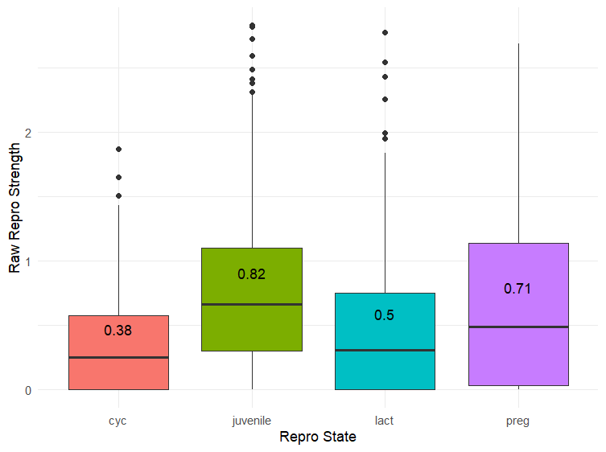

Raw reproductive strength across individuals

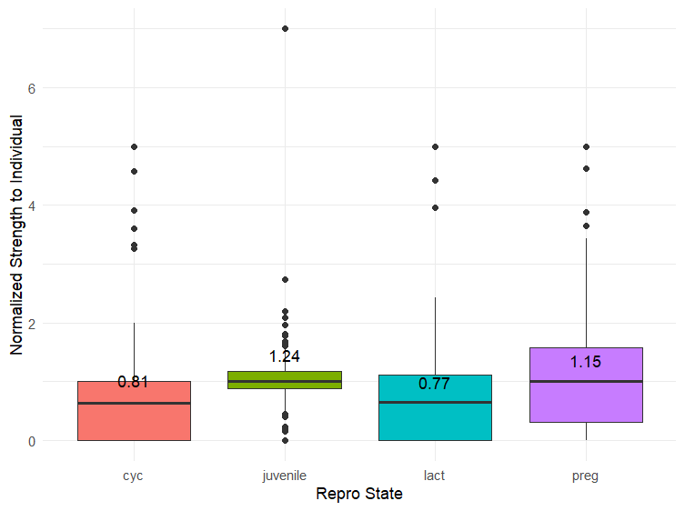

Normalized repro strength to the individual (raw repro strength of individual in each stage / Average repro strength per individual across all stages)

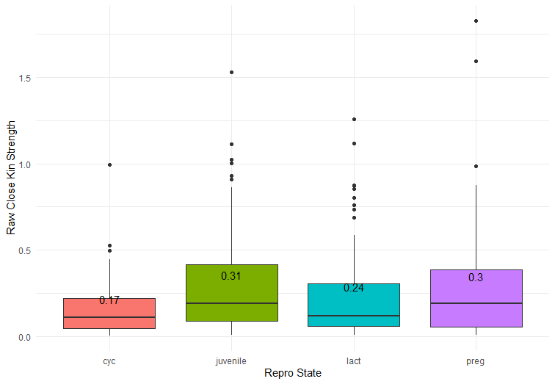

Raw close kin strength across individuals across repro state

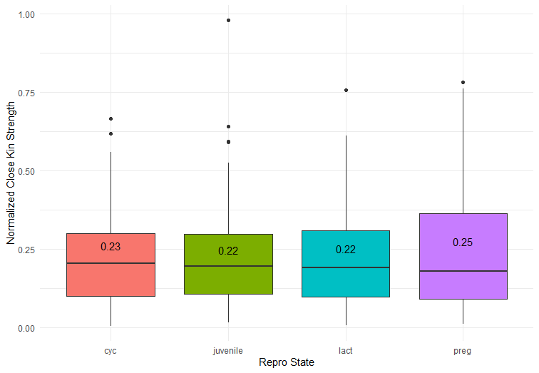

Normalized close kin strength (kin strength of combined ID of individual / total strength of combined ID of individual) across repro state

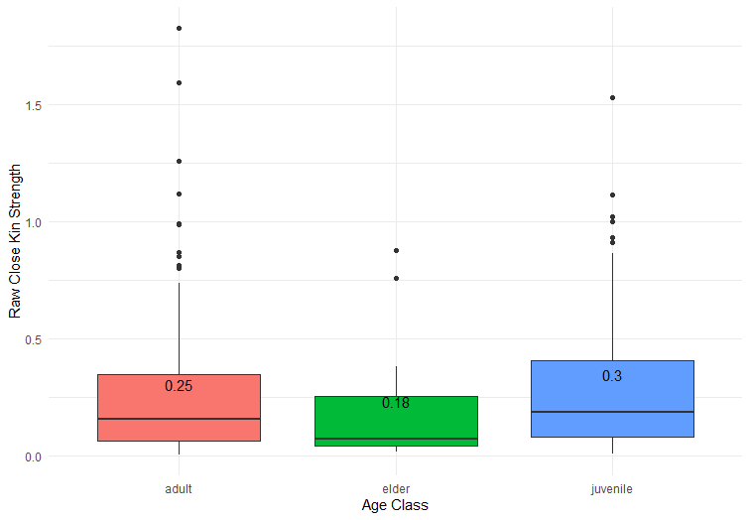

Raw close kin strength across individuals across age class

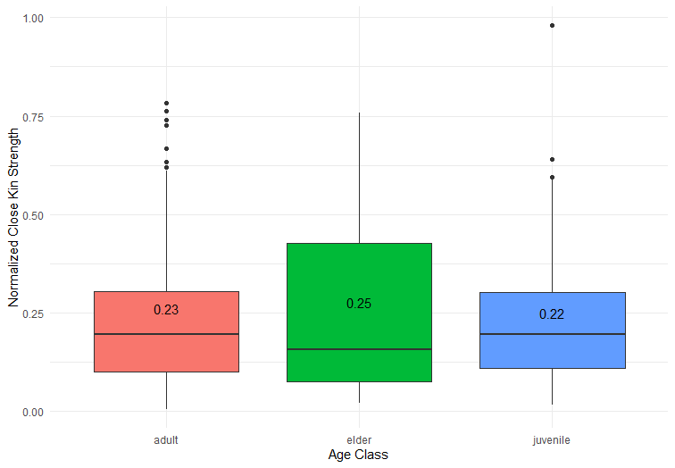

Normalized close kin strength (kin strength of combined ID of individual / total strength of combined ID of individual) across age class

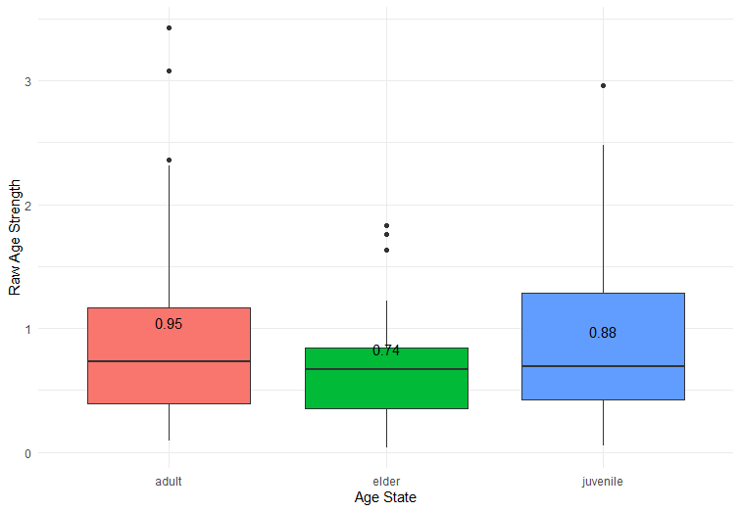

Raw age strength across age class across individuals

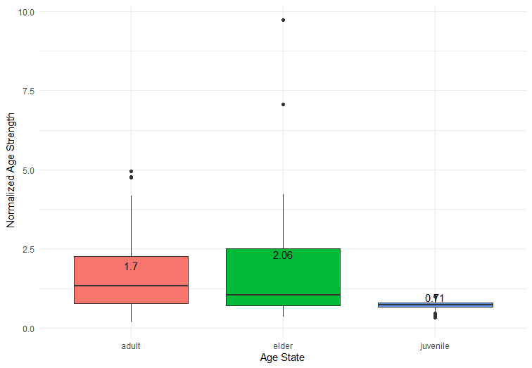

Normalized age strength (age strength individual / total strength of combined ID of individual)

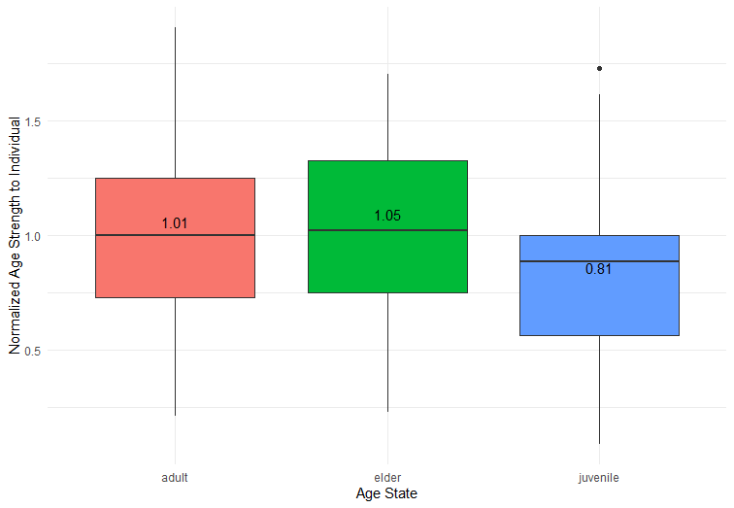

Normalized age strength to the individual (raw age strength of individual in each age class / Average age strength per individual across all age classes)

ANOVA Results

* Repro
  + \*\*\* stat significant difference in repro strength across repro states (F – 8)
  + Groups that are statistically significant
    - Preg-juvenile (p = 0.03)
    - Lact-juvenile \*\*\*
    - Juvenile-cyc (p=0.017)
* Kin
  + \*\*\* stat significant difference in relatedness across close kin (F-13821)
  + No significant difference of norm close kin strength against age class
* Age
  + \*\*\* stat significant difference in norm age strength across age classes (F-25)
  + Groups stat significant difference
    - Juvenile – adult \*\*\*
    - Juvenile – elder \*\*\*
  + No significant difference between groups when using raw age strength
* Repro: Same state vs Different State
  + \*\*\* statistically significant in edge weight across shared vs diff state
  + With shared state and interaction bt close kin, not significant
  + \*\*\* statistically significant in edge weight (of repro pairs) across close vs not close kin

